Livestreaming in Adobe Connect
Our school conducts classes virtually with students who live all over the state of Georgia. Teachers host field trips throughout the year in varying regions within Georgia to provide opportunities for students in different regions to participate on field trips. Even though we do this to increase opportunities for students, there are often students who cannot attend due to financial or travel reasons. One of our school values is “Effective acquisition and efficient use of resources.” This workshop will show teachers how to live stream field trips into their Adobe Connect classroom using the webcam on their cell phones.

Members of the middle school faculty were invited to attend a workshop during our monthly in-person faculty meeting.
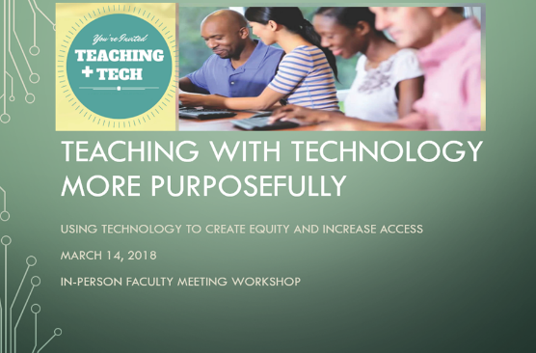

Prior to beginning the workshop, the attending faculty members logged into my Adobe Connect Classroom. Five teachers from Georgia Connections Academy Middle School attended the workshop. Three of the teachers were from the social studies department and two were from the math department. The workshop took place during one of our monthly in-person all-day faculty meetings. The workshop began by establishing the purpose for the workshop, which is to create equity and increase access for our students. To show attendees what an ideal live stream could look like, I showed a brief video clip of a field trip at the High Museum of Art in Atlanta in my Adobe Connect class.
I walked teachers through the steps of
  - Accessing Adobe Connect mobile,
  - Setting the webcam in Adobe Connect mobile to livestream/broadcast,
  - Assigning ‘presenter’ permissions in the Adobe Connect class for the user/cell phone,
  - Communicating with students during the live streaming,
  - Pausing and ending live streaming session

At this point in the workshop the attendees and I participated in a Q and A session discussing opportunities and suggestions for live streaming. One of the attendees performed live streaming ‘guided tour’ of our dining facilities using Adobe Connect mobile on a cell phone while the attendees commented and asked questions in the Adobe Connect class. At the end of the workshop I provided a link to a Google form for attendees to evaluate the workshop. Two faculty members (social studies and language arts) who could not attend the initial workshop, asked if they could learn about what I presented. I immediately sent them the link to the recording of the workshop and the embedded the PowerPoint. (Just to note, there are six members of the social studies department and all but one attended or viewed the recording.)
Survey results from Google form.
The two individuals who viewed the recording of the workshop, based on the data, did not complete the survey. They did provide verbal feedback (Verbal 1 and Verbal 2).
I was pleased to learn that 100 percent of the attendees found the information useful.

One of the important parts of the workshop is creating buy-in for the purpose of creating equity and increasing access integrating technology for fieldtrips. It was important for me that the teachers understood why this workshop topic was selected.

One of the topics discussed during the Q and A part of workshop was the creation of a Google Share Drive folder of video recordings from field trips. Teachers could use the videos or portions of the videos in their instruction or teachers could conduct virtual field trips during their synchronous classes.
Fifty percent of the attendees did not correctly answer this question. I met briefly with each attendee individually after reading this response to clarify this important step in the instructions.
Using this feedback, I created a “boilerplate” request for permission form and I provided the PowerPoint as an additional handout.

The workshop was highly useful based on the comments from the attendees. I initially planned on sharing the link of the recording with the attendees and others. Based on constructive feedback from Verbal 1, I have not shared the recording with others due to the background noise. After listening to the recording, I realized that it would be difficult for a person solely listening to the recording, to hear and understand everything that I was attempting to convey. Due to constructive feedback from the Verbal 2, I modified the original PowerPoint by reducing the visual distractions in it, before sharing it with all the attendees.

Handout

