Current Reality and GAPSS for Georgia Connections Academy
Erika Drake
Kennesaw State University

Georgia Connections Academy (GACA) is a K-12 tuition-free, online charter school. It is accredited by the Southern Association of Colleges & Schools Council on Accreditation and School Improvement, an accrediting division of AdvancED. The Georgia Charter School Commission approved its initial enrollment to begin in the 2011-2012 school year. GACA initially serviced grades K-8 and in the 2012-2013 school year it began servicing students in grades 9-12. The attendance for the school is statewide and all students must have a residence in the state of Georgia. Students must provide their own computer and have reliable internet service. Most of the coursework is provided electronically however, students are shipped a limited amount of physical materials that vary by grade level and course. Connexus is GACA’s online education management system. Connexus provides to access several imbedded resources including: Pearson Education, Inc. digital curriculum BrainPop® videos, quizzes and activities, Discovery EducationTM videos, Grolier OnlineTM The New Book of Knowledge articles, and EBSCOhost research databases. GACA Middle School services grades 6-8.
Teachers educate and communicate with students using a variety of technology rich systems. Teachers communicate with students and families via the closed Connexus-based webmail system and via Google Voice. In addition, each teacher hosts minimally one weekly group LiveLesson® via Adobe Connect. Teachers also have access to provide students with assignments via Study Island and USA TestPrep. GACA Middle School staff collaborates with in-person meetings, virtual meetings via Adobe Connect, Google Hangouts and via the Google suite of products from Gmail, Google Calendar, Google Drive, etc. The teachers and staff use the data from Google Voice formative assessments, LiveLesson formative assessments, Connexus online assessments and the use of GoFar in the Georgia Student Longitudinal Data System (SLDS) to drive personalized instruction. The school does not have a formal technology plan. The vision of Georgia Connections Academy is for all students to graduate prepared for their chosen college or career experience. The mission of Georgia Connections Academy is to exemplify a collaborative virtual school where the students meet high expectations through mastery of challenging material in preparation for successful college and career experiences.
Professional Learning
Professional learning teams, book studies, workshops, conferences, and coaching and mentoring are utilized to provide professional learning. Several times a year, GACA Middle School administration gives a “Needs Assessment” survey to the faculty to identify professional development needs of staff. The administration uses the information gathered from the surveys, along with student data to support professional learning opportunities. Surveys are administered to staff via Google Forms and the Director of School Improvement creates and implements a plan to help teachers perform duties needed to help students achieve GACA Middle School’s goals. Professional learning occurs during our monthly in-person faculty meeting days and virtually via Adobe Connect. After professional development training teachers provide feedback during a Question and Answer period or they complete surveys via Google Forms on what they learned from the sessions, if the teachers require additional information, and on how the sessions could be improved. Administrators observe LiveLessons to confirm that concepts and skills from professional learning are being implemented. Administrators analyze student data to determine student growth. No financial incentive accompanies the onsite/virtual professional learning opportunities and they are mandatory. Funding is provided via a hybrid of teacher/administrator salaries and Title II funds.
Teachers receive ongoing professional learning via the Connections Academy (CA) corporate learning management system based on the number years of service with CA. As a second-year employee, the Professional Learning 200 Series focuses on the Learning Sciences. The Series produces LiveLesson sessions on growth mindset, engaging students with higher-level questions, providing effect and deliberate practice opportunities and designing motivational feedback. After each professional learning session, teachers complete Post-Session activities and forms on the Connexus system. They explain what they learned from the professional learning experience and how they will implement what was learned with students. No financial incentive accompanies these CA Adobe Connect professional learning opportunities and they are mandatory. Administrators observe course LiveLessons to confirm that concepts and skills from professional learning are being implemented. Administrators also have the option to provide feedback to teachers’ responses on the Connexus system. Administrators analyze student data to determine student growth. Funding for these sessions is provided by CA. As an incentive for retention and to support career advancement, CA also provides tuition reimbursement for full-time employees who wish to continue learning through job related college courses, from an accredited college or university, at the undergraduate and graduate levels up to $5, 250 per calendar year.
Teachers can request to attend professional learning opportunities and conferences that will support students with disabilities, ELL, gifted, migrant, economically disadvantaged, RTI, SST, English Language Arts, Reading, Math, Science, Social Studies. To date, this 2017-2018 school year, administrators, teachers and staff have attended: Google professional learning sessions, the Solution Tree Conference: Daily Differentiation Tier I, Georgia RESA IT Conference, Georgia Council of the Social Studies Annual Conference, Georgia STEM Forum, Georgia Educational Technology Conference, Metro RESA West VR, Coding and 3D Modeling workshop, Georgia Mathematics Conference, Georgia School Counselor Association Conference, Reading, Literacy, & Learning Conference of the International Dyslexia Association, Georgia Art Educators Conference, and the Annual Conference for Middle Level Education. As an incentive, GACA pays for the conference fees, food, travel and hotel accommodations related to these workshops and conferences. In the spring of 2017 the GACA Middle School principal asked for volunteers to become gifted certified and as an incentive GACA will pay for this certification. After professional learning, teachers complete Professional Learning/Conference Review forms explaining what they learned from the professional learning experience and how the teacher will implement what was learned with students. Administrators observe course LiveLessons to confirm that concepts and skills from professional learning are being implemented. Administrators analyze student data to determine student growth. Funding for external professional learning/conferences is provided by Title II funds.
At the 2017 Georgia Educational Technology Conference, Jaime Casap - Google Innovator, said, “We need to make sure that technology should be there to support and enable great learning.…We need to focus on building the skills that teachers need so that they can take advantage of that technology and create the learning models that will help prepare students for the next economy.” During this school year, the administration recognized the desire of several of our teachers to become STEM/STEAM certified. As a result, a STEM/STEAM committee was formed and the teachers on this committee began attending conferences, many are mentioned above. The administration also approved for four teachers begin the process of obtaining STEM Certification. The committee began working with a variety of software development companies to plan the process of how the remaining staff can become STEM/STEAM certified and add a STEM/STEAM track of courses for our students. This plan will allow future students to be successfully prepared to enter the STEAM Academy which is being implemented for the 2018-2019 year in the GACA High School. Funding for the certifications, workshops and conferences is provided by Title II funds. Part of the purpose of Title II, part A grant is “to increase student achievement consistent with challenging State academic standards and to improve the quality and effectiveness of teacher, principals and other school leaders.” (“Title II, Part A,” GADOE) The allocation of Title II funds from the GADOE for GACA was $96,245 for the 2018FY. These funds are then distributed amongst the GACA Elementary School, the GACA Middle School and the GACA High School.
Diversity and Collaboration
During professional learning opportunities, the Special Education Department offers training for the general education teachers. These sessions occur during in-person and virtual district and school level meetings. During the most recent session, the special education instructor explained to us the type of stimuli that inhibit learning for some of students with sensory processing issues. She then demonstrated with the group one of GACAs and most frequently used LiveLesson test review games, Kahoot! Most of the students love it and request it often. As we played the game, we were instructed to list the distractors and analyze the possible impact of Kahoot! on our students with sensory issues. We noted there was background music, sounders when students select answers and when the page changes. The screen changes color every few seconds as well. Based on what we learned from the session, every teacher immediately began to comment and formulated a plan to eliminate as many of the distractors from LiveLessons as possible to meet the needs of the students.
In GACA Middle School there are two teams for each grade level. For each content area, Team A includes a general education teacher and a special education teacher, they service both general education students, gifted students and students with IEPs, and Team B includes a general education teacher, who services general education students, gifted students and students with 504 plans. Each learning team in GACA Middle School is comprised of two general education teachers and one special education teacher. The learning team meets at least once a week for planning and data analysis via Google Hangouts. During the vertical team meetings, the teachers use the screen share option to review the course calendar and plan future LiveLesson content and activities. They review student data to determine what areas need remediation or extension with students. This year, teachers are required to teach one LiveLesson per week for Social Studies. In general, the teachers from team A collaboratively host a Live Lesson once a week and the teacher from Team B hosts a live lesson once a week at the same time. During test reviews and on other occasions, as the need requires, all three teachers host the LiveLesson class together. They use the Question & Answer pod, poll pods, document share pod, screen share pod, provide microphone rights and a provide a modified Kahoot! to communicate, assist, review and formatively assess students. As teachers, we also have the autonomy to host one-on-one, small group, or task specific LiveLesson sessions with our students as needed. After a conversation with a parent and the student regarding the student being behind in class and having a failing grade, we established a plan for weekly one-on-one sessions for the student to remediate, learn skills, and create a plan for catching up in class.
Teachers on Team B meet bi-weekly in Adobe Connect in Hangouts to discuss student data, receive administrative tasks, receive professional learning and collaborate on past issues or plan for future goals. Based on a directive from our administration we were instructed to have our students complete an assessment on the SLDS platform. We were provided with a timeline and professional development on how to access, create, assign and manage the GoFAR assessment on the SLDS system. GACA is using GoFAR assessment uses standards-based questions created by the GADOE as a diagnostic benchmark for students, as we aim to increase student success in mastering knowledge and skills from the GA Standards of Excellence and increase successful performance on the GA Milestones. We meet as a team in hangouts to discuss how to help struggling students. Prior to conferencing with students and the students’ caretakers, we collaborate on a document in the Google Share drive that provides updated grades, grade improvement and remediation suggestions from all subject areas. We then conference with the family via hangouts and/or Adobe Connect to answer student and caretaker questions and provide suggestions for improvement. We then webmail the Google Drive document with suggestions to the families after additional changes are made based on the conference and later we follow-up as needed.
Teachers have an informal ease of communication with each other, supervisors and administrators across grade levels and content areas by using Google Hangouts and the Google Share Drive. We use Google Hangout multiple times daily to ask each other questions, provide support to our colleagues, collaborate on problems and praise each other’s successes. We use the Google Share Drive as a source of information for FAQ for each content area, to list skipped assignments as students transfer into school, to collaborate on documents for grade- or school-wide assignments and to share resources. The administrators, teachers and staff at Georgia Connections Academy meet every morning at 8:00 A.M. in Adobe Connect to share our vision, our mission, our values and to encourage each other. It helps us start our day with purpose and that purpose is focused on student success.

Appendix
Professional Learning 200 Level Series Follow-up Form
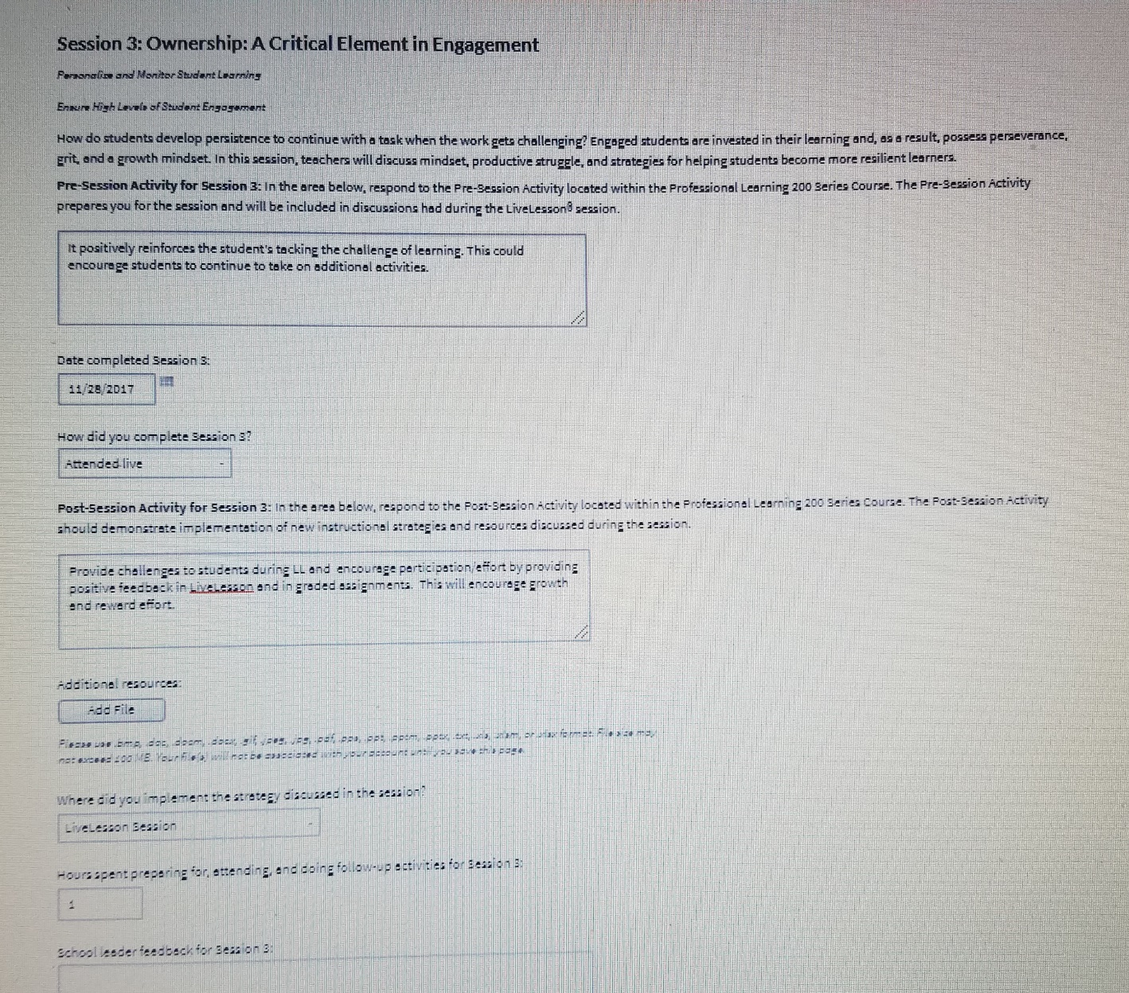

Georgia Connections Academy Conference Follow-up Form
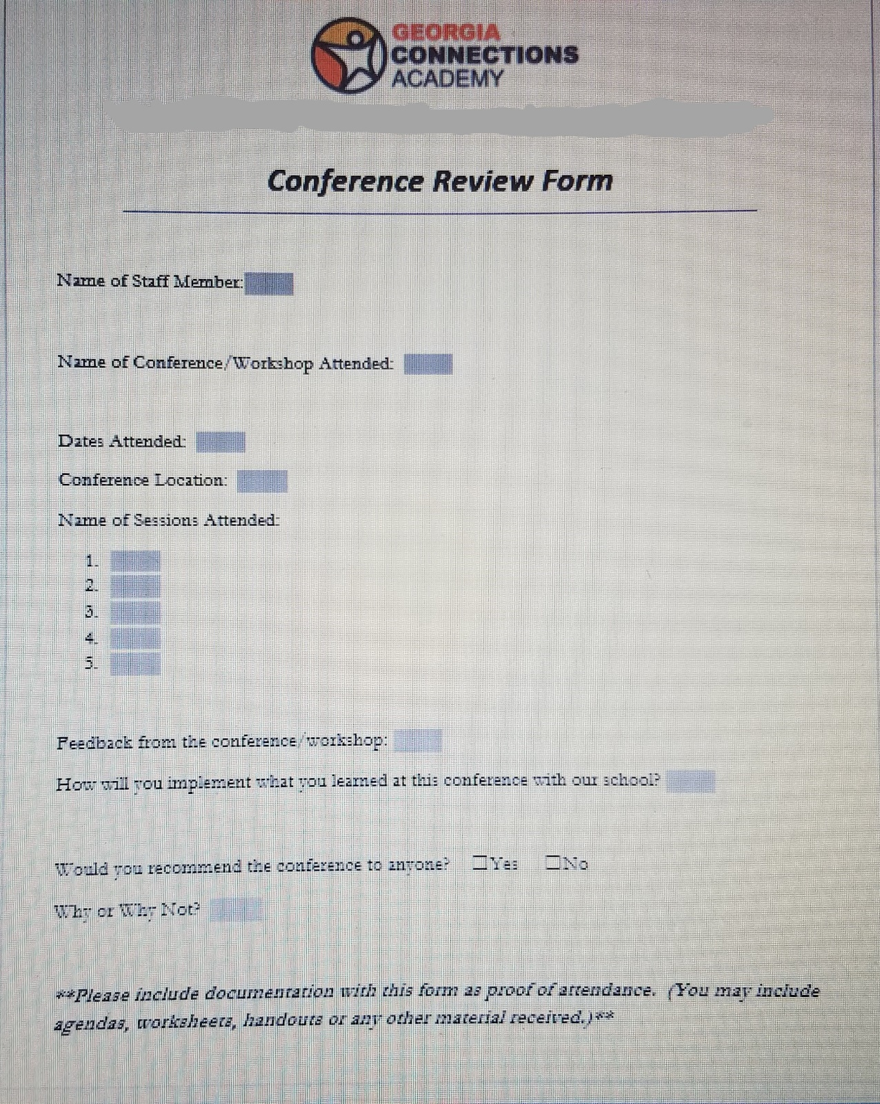

Kahoot! Formative Assessment Game
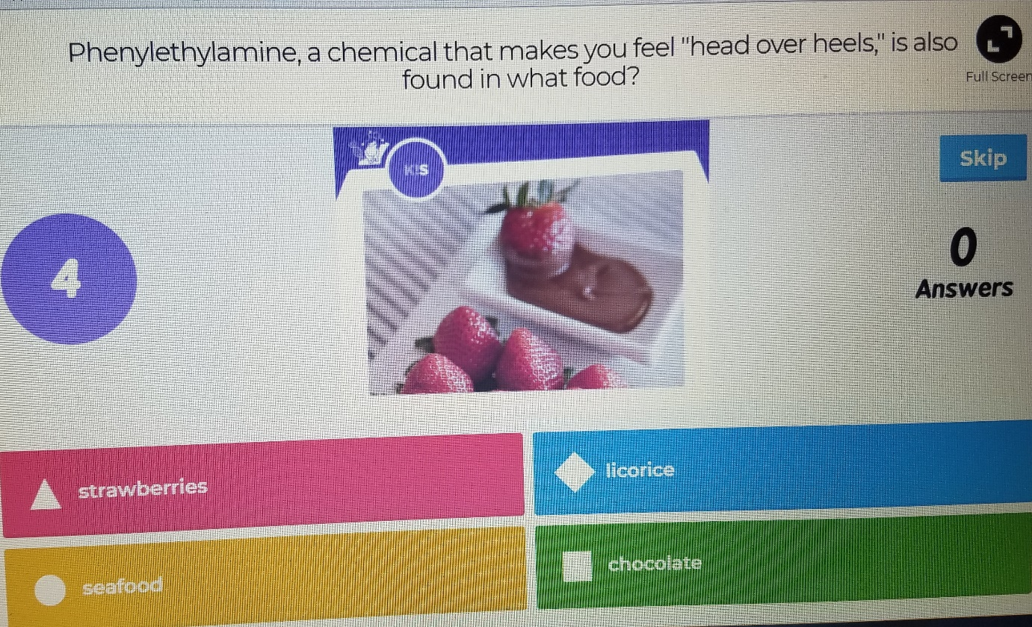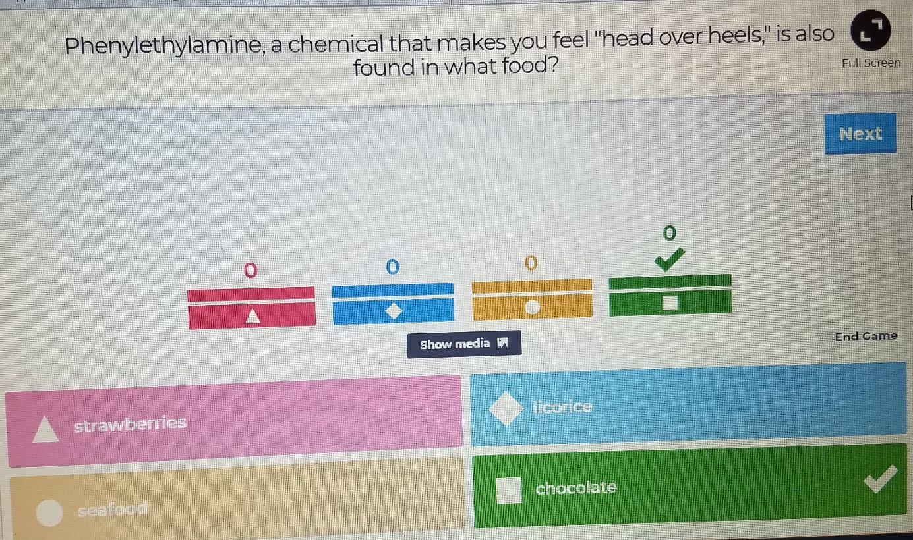

PROFESSIONAL LEARNING
The means by which teachers, administrators, and other staff acquire, enhance, and refine the knowledge, skills, practices, and dispositions necessary to create and support high levels of learning for all students

Professional Learning Standard 1: Aligns professional learning with needs identified through analysis of a variety of data
Level 4  Exemplary | Level 3  Operational | Level 2  Emerging | Level 1  Not Evident
Professional learning needs are identified and differentiated through a collaborative analysis process using a variety of data (e.g., student achievement data, examination of student work, process data, teacher and leader effectiveness data, action research data, perception data from students, staff, and families). Ongoing support is provided through differentiated professional learning. | Professional learning needs are identified through a collaborative analysis process using a variety of data (e.g., student achievement data, examination of student work, process data, teacher and leader effectiveness data, action research data, perception data from students, staff, and families). | Professional learning needs are identified using limited sources of data. | Professional learning needs are identified using little or no data.
EVIDENCE: Survey to staff regarding desires for in-office professional development is administered once or twice a year; at the end of the school year and at the beginning of the year.
RECOMMENDATIONS: Select a trained staff member to meet with and collaborate with teacher teams in discussing data and helping with strategies to meet the needs of students. (Using Student Achievement Data to Support Instructional Decision Making, NAESP)

Professional Learning Standard 2: Establishes a culture of collaboration among administrators and staff to enhance individual and collective performance
Level 4  Exemplary | Level 3  Operational | Level 2  Emerging | Level 1  Not Evident
Administrators and staff, as a foundational practice, consistently collaborate to support leadership and personal accountability and to enhance individual and collective performance (e.g., construct knowledge, acquire skills, refine practice, provide feedback).  Teachers conduct action research and assume ownership of professional learning processes. | Administrators and staff routinely collaborate to improve individual and collective performance (e.g., construct knowledge, acquire skills, refine practice, provide feedback). | Administrators and staff routinely collaborate to improve individual and collective performance (e.g., construct knowledge, acquire skills, refine practice, provide feedback). | Administrators and staff routinely collaborate to improve individual and collective performance (e.g., construct knowledge, acquire skills, refine practice, provide feedback).
EVIDENCE: Teachers and administrators collaborate with each other daily for the goal of student success through Google Hangout, Adobe Connect, and the Google Share Drive. Teachers and staff provide feedback on professional development and are held accountable for implementing processes learned with students based on observations and data.
RECOMMENDATIONS: Administrator and teachers plan time during in-person meetings to develop action plans for changes that are discussed during weekly collaboration.

Professional Learning Standard 3: Defines expectations for implementing professional learning
Level 4  Exemplary | Level 3  Operational | Level 2  Emerging | Level 1  Not Evident
Administrators, teacher leaders, or both consistently define expectations for the implementation of professional learning, including details regarding the stages of implementation and how monitoring will occur as implementation progresses. | Administrators, teacher leaders, or both regularly define expectations for the implementation of professional learning. | Administrators, teacher leaders, or both occasionally define expectations for the implementation of professional learning. | Administrators, teacher leaders, or both rarely, if ever, define expectations for the implementation of professional learning.
EVIDENCE: Images in appendix represent forms that are completed by staff after professional development and school principal states observation and student data serve as a metric for how monitoring will occur and is assessed, however there is no evidence provided to teachers.
RECOMMENDATIONS: Feedback from supervisor or principal regarding the stages, levels, and or quality of implementation of professional learning should be provided to teachers in order for teachers to improve instruction.

Professional Learning Standard 4: Uses multiple professional learning designs to support the various learning needs of the staff
Level 4  Exemplary | Level 3  Operational | Level 2  Emerging | Level 1  Not Evident
Staff members actively participate in job-embedded professional learning that engages collaborative teams in a variety of appropriate learning designs (e.g., collaborative lesson study, analysis of student work, problem solving sessions, curriculum development, coursework, action research, classroom observations, online networks). Professional learning includes extensive follow-up with descriptive feedback and coaching. | Staff members actively participate in professional learning, most of which is job-embedded, which includes multiple designs (e.g., collaborative lesson study, analysis of student work, problem-solving sessions, curriculum development, coursework, action research, classroom observations, online networks) to support their various learning needs. Professional learning includes follow-up with feedback and coaching. | Some staff members are engaged in professional learning that makes use of more than one learning design to address their identified needs. | Staff members receive single, stand-alone professional learning events that are informational and mostly large-group presentation designs.
EVIDENCE: Georgia Connections Academy and Connections Academy provides and abundance and variety of professional learning opportunities for its administrators and teachers.
RECOMMENDATIONS: Additional or optional forms of professional development and implementation of strategies learned from professional learning should be offered for teachers, such as peer observation of LiveLessons, planning time for curriculum modification, and collaboration with successful CA school across the nation.

Professional Learning Standard 5: Allocates resources and establishes systems to support and sustain effective professional learning
Level 4  Exemplary | Level 3  Operational | Level 2  Emerging | Level 1  Not Evident
Extensive resources (e.g., substitute teachers, materials, handouts, tools, stipends, facilitators, technology) and systems (e.g., conducive schedules, adequate collaborative time, model classrooms) are allocated to support and sustain effective professional learning. Opportunities to practice skills, receive follow-up, feedback, and coaching are provided to support the effectiveness of professional learning. | Adequate resources (e.g., substitute teachers, materials, handouts, tools, stipends, facilitators, technology) and systems (e.g., conducive schedules, adequate collaborative time, model classrooms) are in place to support and sustain professional learning. | Some resources and systems are allocated to support and sustain professional learning. | Few, if any, resources and systems are provided to support and sustain professional learning.
EVIDENCE: Since GACA is a virtual school some of the resources that other schools struggle with because funds go towards physical structures are not problems with GACA.
RECOMMENDATIONS: Opportunities to receive teacher specific feedback, follow-up and coaching should be provided for teachers to improve teaching and student learning.

Professional Learning Standard 6: Monitors and evaluates the impact of professional learning on staff practices and student learning
Level 4  Exemplary | Level 3  Operational | Level 2  Emerging | Level 1  Not Evident
Monitoring and evaluating the impact of professional learning on staff practices and increases in student learning occurs extensively. Evaluation results are used to identify and implement processes to extend student learning. | Monitoring and evaluating the impact of professional learning on staff practices and student learning occurs routinely. | Monitoring and evaluating the impact of professional learning on staff practices occurs sporadically. | Monitoring and evaluating the impact of professional learning on staff practices occurs rarely, if ever.
EVIDENCE: In the space below, provide detailed evidence supporting your rating above –
RECOMMENDATIONS: Feedback on evaluation of teacher implementation of professional learning should be provided to teachers to extend student learning.

KSU ITEC Professional Learning Standard: Professional learning reinforces educators’ understanding and use of strategies for promoting equity and high expectations for all students, application of research-based teaching strategies and assessment processes, and involvement of families and other stakeholders in promoting student learning.
Level 4  Exemplary | Level 3  Operational | Level 2  Emerging | Level 1  Not Evident
Classroom practices (e.g., considering interests, backgrounds, strengths, and preferences to provide meaningful, relevant lessons and assess student progress, differentiating instruction, and nurturing student capacity for self-management) of all teachers reflect an emotionally and physically safe environment where respect and appreciation for a diverse population is evident. There are high achievement expectations for all students and teachers. The principal and other leaders provide professional learning for teachers lacking understanding of the impact that attitudes regarding race, disabilities, background, culture, high expectations, and social class of both students and teachers have on the teaching and learning process. | Classroom practices of most teachers reflect skill in communicating high expectations for each student and adjusting classroom activities to meet student needs. Respect for students’ cultures and life experiences is evident through the emotionally and physically safe learning environment where students of diverse backgrounds and experiences are taught the school code of conduct (customs) to help them be successful in the school context. | Classroom practices of some  teachers reflect evidence of teachers’ training in understanding the impact that attitudes regarding race, disabilities, background, culture, high expectations, and social class of both students and teachers have on the teaching and learning process. | Classroom practices reflect little or no evidence of teachers’ training in understanding the impact that attitudes regarding race, disabilities, background, culture, high expectations, and social class of both students and teachers have on the teaching and learning process.
EVIDENCE: Every year teachers either serve the needs of students with 504 plans or students with and IEP and each teacher serves the needs of Gifted students every year. Based on communication with families a significant number of students who attend GACA come to the school to escape bullying in the brick and mortar setting. All the teachers at GACA understand the varying abilities, socioeconomic characteristics and talents of the students and we adjust our direct student communication and courses to meet their needs. In our LiveLessons we do not expressly address the issues related to culturally responsive pedagogy as it relates to the cultures of our students. There is a disconnect in that area.
RECOMMENDATIONS: We should reach out to our families to recognize accomplishments, birthdays, holidays, etc. and address them in our weekly enewsletter and LiveLessons.

