Name: E. Drake Semester: Fall 2018
ESSENTIAL CONDITION ONE: Effective Instructional Uses of Technology Embedded in Standards-Based,
Student-Centered Learning

ISTE Definition: Use of information and communication technology (ICT) to facilitate engaging approaches to learning.
Guiding Questions:
- How is technology being used in our school? How frequently is it being used? By whom? For what purposes?
- To what extent is student technology use targeted toward student achievement of the Georgia Standards of Excellence (GPSs, CCSs)?
- To what extent is student technology use aligned to research-based, best practices that are most likely to support student engagement, deep understanding of content, and transfer of knowledge? Is day-to-day instruction aligned to research-based best practices?

Strengths | Weaknesses | Opportunities | Threats
- Technology is used for everything at our school. Technology is used daily by teachers and students.  - Teacher create lessons, instruct and assess students and collaborate using technology.  - Students use technology to learn content, complete assessments and communicate with teachers.  - Most student technology is aligned towards student achievement of the Georgia Standards of Excellence and most day to day instruction is aligned with best practices. | - Some of the lessons in our LMS are not directly correlated to the Georgia Standards of Excellence.  - Teachers evaluate the lessons each year to create additional lessons and assignments as needed to ensure all the Georgia Standards of Excellence are addressed. | - Some teachers have completely created new research-based assignments for students based on best practices. | - Some teachers use their synchronous class time to lecture students instead of engaging them with research based best practices.
Summary of Results/Conclusions:

The school’s uses the technological resources of the LMS to provide the majority of the content and assessments for students. The majority of the content in the LMS is aligned with the Georgia Standards of Excellence (GSE). After teachers evaluate all the lessons, they create addendums to student LMS lessons to cover the remaining GSE standards. Some content area teachers have created standards-based new assignments for the students. Most teachers use their synchronous time to engage with students and support their learning by incorporating activities based on best practices. Some teachers do not use best practices in their synchronous time.

Recommendations from Gap Analysis:

Teachers who are not using best practices in their synchronous sessions should be supported by master teachers and provided with professional development.

Supporting Sources:

Drake, E. (2018) Personal communication.

Searby, L. J., & Brondyk, S.K. (2016). Best practices in mentoring for teacher and leader development. Charlotte, NC: IAP
Information Age Publishing.

ESSENTIAL CONDITION TWO: Shared Vision

ISTE Definition: Proactive leadership in developing a shared vision for educational technology among school personnel, students, parents, and the community.
Guiding Questions:
- Is there an official vision for technology use in the district/school? Is it aligned to research-best practices? Is it aligned to state and national visions? Are teachers, administrators, parents, students, and other community members aware of the vision?
- To what extent do teachers, administrators, parents, students, and other community members have a vision for how technology can be used to enhance student learning? What do they believe about technology and what types of technology uses we should encourage in the future? Are their visions similar or different? To what extent are their beliefs about these ideal, preferred technology uses in the future aligned to research and best practice?
- To what extent do educators view technology as critical for improving student achievement of the GPS/CCSs? To preparing tomorrow’s workforce? For motivating digital-age learners?
- What strategies have been deployed to date to create a research-based shared vision?
- What needs to be done to achieve broad-scale adoption of a research-based vision for technology use that is likely to lead to improved student achievement?

Strengths | Weaknesses | Opportunities | Threats
- Teachers, administrators, parents and students believe that technology is critical for improving student achievement at our school because they chose to work, bring their children or attend our school, a virtual school.  - Preparing students to become a part of tomorrows workforce is a part of our vision and mission.  - The vision of the school is for all students to graduate prepared for their chosen college or career experience.  - This vision is believed and shared with administrators, teachers and community stakeholders.  - We state the vision at the beginning of every school day during our morning meeting and it ties into our school mission.  - Our school mission is to exemplify a collaborative virtual school where our students meet high expectations through mastery of challenging academic material in preparation for successful college and career experiences. | - Teachers do not receive feedback from parents or students regarding a vision for how technology can be used to enhance student learning. | Our school has the resources to assess the student and parental version of a vision for our school. | - No there is no official vision for technology use in the district.  - Some students are not self-motivated, which is essential for online learning.
Summary of Results/Conclusions:
The vision and mission of our school is directly correlated to helping our students achieve success as we prepare them to become tomorrow’s workforce. Even though our school is an online school there is no formal technology plan or vision for technology use by the district. The administration and select teachers determine which supplemental resources we will use to support students learning.

Recommendations from Gap Analysis:

Even though we want students and families to decide to come to our school, perhaps a survey could be created that provides feedback to students who are not self-motivated to explain that our school may not be the best fit.

Supporting Sources:

Drake. E. (2018). Shared Vision & Rationale. Unpublished manuscript. Kennesaw State University

Moersch, C. (2014). Improving Achievement with Digital Age Best Practices. 55 City Road, London: SAGE Publications, Ltd.

ISTE. (2018). Diagnostic Tool Results: Results for GACA 10.28.18. Retrieved from https://www.iste.org/standards/lead-transform/diagnostic-tool/results

ESSENTIAL CONDITION THREE: Planning for Technology

ISTE Definition: A systematic plan aligned with a shared vision for school effectiveness and student learning through the infusion of ICT and digital learning resources.
Guiding Questions:
- Is there an adequate plan to guide technology use in your school? (either at the district or school level? Integrated into SIP?)
- What should be done to strengthen planning?
- In what ways does your school address the needs of diverse populations in the school or district to include how race, gender, socio-economic, and geographic diversity giving consideration to how these factors commonly affect K-12 students’ access to school and beyond-school access to high-speed Internet, modern computing devices, software, knowledgeable technology mentors, culturally-relevant digital content, and other affordances critical to technology literacy acquisition.

Strengths | Weaknesses | Opportunities | Threats
- The school is an online school and has technology integrated into the SIP.  - In addition to the LMS, the SIP also includes the use of USA TestPrep, Math XL and SuccessMaker to help struggling students achieve success.  - In order to attend our school, parents agree to provide technology and internet access to students.  - Our LMS provides a variety of culturally and technologically diverse scenarios for students to interact with while progressing through lessons. | - If a student loses access to technology or internet access the school does not have any program to assist them. However, the school administrators and teachers will allow families time to acquire technology and or internet access without the student receiving reduced scores for late assignments.  - Students are permitted to submit presentations using little technology which does not increase their digital literacy skills.  - The number of student presentations for students to show mastery is limited. | - Students can acquire additional digital literacy skills while completing presentations.  - Differentiation is available for students to submit presentations in a variety of formats for evaluation via rubric.  - Our school has provided an Ed Tech course in the past which taught students technology skills they could use for school. | - The school does not specifically address the needs of any of our diverse populations.  - The school does not research or plan how to increase success of students from diverse populations.
Summary of Results/Conclusions:

The technology plan is integrated into the School improvement plan at our virtual school. The school is does not specifically address any of the needs of the diverse population. All students have access to technological resources at school and culturally-relevant digital content. However, even though our students work in a technology rich environment. They are not required to increase their digital literacy.

Recommendations from Gap Analysis:

Teachers should use data for each segment of our diverse populations to guide planning for student interventions and engagement.
Teachers should create additional authentic assignments that would increase the digital literacy of our students.

Supporting Sources:

Moersch, C. (2014). Improving Achievement With Digital Age Best Practices. 55 City Road, London: SAGE Publications, Ltd.

Weatherspoon, T. & Wilcox, A. (2018). Middle School Improvement Plan. Unpublished manuscript.

ESSENTIAL CONDITION FOUR: Equitable Access (Specifically Low SES and gender groups)

ISTE Definition: Robust and reliable access to current and emerging technologies and digital resources.
Guiding Questions:
- To what extent do students, teachers, administrators, and parents have access to computers and digital resources necessary to support engaging, standards-based, student-centered learning?
- To what extent is technology arrange/distributed to maximize access for engaging, standards-based, student-centered learning?
- What tools are needed and why?
- To what extent are strategies needed to address equity issues among Low SES and gender groups? What are examples of strategies that would benefit your school/district? (required)
- Do students/parents/community need/have beyond school access to support the shared vision for learning?

Strengths | Weaknesses | Opportunities | Threats
- All students, teachers, administrators and parents have access to computers and digital resources to supporting engaging standards- based student-centered learning.  - All students have equal access to the LMS for learning.  - Tools required for learning by students are desktop/laptop, high speed internet, access to the LMS.  - The Math Milestone Scores for our girls is higher than the general population of students.  - The school has started a Girls Who Code club to provide support for girls at our school. It also aims to increase the number of women in the tech industry. | - Some students who do not have the resources take longer to replace technology when it is in need of repair or replacement due to lack of funds.  - Data does not indicate however that Low SES students miss more days than the general student population. | - There are third party software venders that students who are struggling with learning the content solely with the LMS such as Math XL, SuccessMaker, and USA TestPrep that are used with our students to support the shared vision for learning.  - The counselors and engagement teachers occasionally meet with families in person at “survivor” sessions to make sure that students and parents understand how to use and access information in our technological environment. | - There are no specific strategies in place to address equity issues among Low SES gender groups.  - Our school data indicates that more students with Low SES earn Beginning Level Scores on the Math Georgia Milestones than the general student population.
Summary of Results/Conclusions:

GACA has a number of strengths for Equitable Access. Students of Low SES and gender have unfettered access to school resources. Girls are performing as well as or better than boys on the Georgia Milestones and a Girls Who Code group has been created to continue the support of girls in technology. There are no specific supports in place for low SES students who are achieving at lower academic levels than the general school population.

Recommendations from Gap Analysis:
Students with low SES could be partnered with Social Workers who could ensure that student have the resources they need to continue working if their computers need repair or replacement. Community partnerships could be created to provide streamlined repair or laptop replacement for little to no costs for low SES students.
Social Workers could also work with students and families to coordinate services with administrators, teachers and other stakeholders to ensure student growth is on par with general population.

Supporting Sources:

Drake. E. (2018). GACA Data Overview. Unpublished document.

Anderson, A., Thomas, D., Moore, D., & Kool, B. (2008). Improvements in school climate associated with enhanced health and welfare services for students. Learning Environments Research, 11(3), 245–256. https://doi-org.proxy.kennesaw.edu /10.1007/s10984-008-9044-5

Girls Who Code. (2018). Girls Who Code: About Us. Retrieved from https:girlswhocode.com/about-us/

ESSENTIAL CONDITION FIVE: Skilled Personnel

ISTE Definition: Educators and support staff skilled in the use of ICT appropriate for their job responsibilities.
Guiding Questions:
- To what extent are educators and support staff skilled in the use of technology appropriate for their job responsibilities?
- What do they currently know and are able to do?
- What are knowledge and skills do they need to acquire?

(Note: No need to discuss professional learning here. Discuss knowledge and skills. This is your needs assessment for professional learning. The essential conditions focus on “personnel,” which includes administrators, staff, technology specialists, and teachers. However, in this limited project, you may be wise to focus primarily or even solely on teachers; although you may choose to address the proficiency of other educators/staff IF the need is critical. You must include an assessment of teacher proficiencies.)
Strengths | Weaknesses | Opportunities | Threats
- Teachers at this school are proficient in using technology to communicate with students and families, to teach students via Adobe Connect synchronous and asynchronous recordings, and to assess students via the LMS.  - All teachers currently know how to perform their job responsibilities using these technologies.  - Teachers are also proficient at using Testpad in SLDS to evaluate student current level of knowledge specific to content and use it to create benchmarks.  - Teachers are proficient with the Microsoft Office Suite of products. | - Teacher knowledge of the Google Suite of products is inconsistent.  - Some teachers use the same programs over and over and do not take the opportunity to learn new programs. | - This year the school began using the Google Suite of products for Education.  - The school rolled out a new weekly newsletter using Google Drawings.  - Teachers have the autonomy to use new technologies with students. | - Some teachers will not learn the new Google Suite of products and will continue to use older resources even if the Google Suite is more efficient.  - Many teachers do not know how to analyze student data from TestPad.  - An administrator analyzes the data and provides the results to teachers for planning purposes.
Summary of Results/Conclusions:

Teachers at GACA know how to use a wide range of technological resources.

Recommendations from Gap Analysis:

Teachers with little experience with software within the Google Suite of products can partner with a teacher with more experience and collaborate on uses of software for student engagement and teacher efficiency. Teachers should know how to analyze student data and should receive training when deficits are discovered.

Supporting Sources:

Dent, W, Drake, E., & Jones, M. (2017) Middle School Adopter Survey. Retrieved from https://docs.google.com/forms/d/e/1FAIpQLSfNDqbnLsF-wUySw6DKr4zr7z9apjSlMF9zqppsWQiBH7BYiQ/viewform .

Dent, W, Drake, E., & Jones, M. (2017) Middle Grades LoTi Survey. Retrieved from https://docs.google.com/forms/d/e/1FAIpQLSf6rlVF1LkmVUNCbH2J8s-aGhv9q5L8b0Qrep8j35Jx34krTA/viewform .

Morrison, J. (2009). Why teachers must be data experts. Educational Leadership.66(4) Retrieved from http://www.ascd.org/publications/educational-leadership/dec08/vol66/num04/Why-Teachers-Must-Be-Data-Experts.aspx

ESSENTIAL CONDITION SIX: Ongoing Professional Learning

ISTE Definition: Technology-related professional learning plans and opportunities with dedicated time to practice and share ideas.
Guiding Questions:
- What professional learning opportunities are available to educators? Are they well-attended? Why or why not?
- Are the current professional learning opportunities matched to the knowledge and skills educators need to acquire? (see Skilled Personnel)
- Do professional learning opportunities reflect the national standards for professional learning (NSDC/Learning Forward)?
- Do educators have both formal and informal opportunities to learn?
- Is technology-related professional learning integrated into all professional learning opportunities or isolated as a separate topic?
- How must professional learning improve/change in order to achieve the shared vision?

Strengths | Weaknesses | Opportunities | Threats
- Teachers are provided with the opportunities to attend several types of professional development opportunities.  - Educators can select to attend any in-state professional development opportunities as long as teachers indicate how students will benefit from the professional development. Many educators take advantage of the opportunity to attend content and technology related conferences.  - In-person professional development for testing is performed throughout the school year and although it is mandatory, teachers are highly engaged.  - Professional development is aligned with some of learning forwards standards such as learning community, resources, outcomes, learning designs and data.  - Teachers have both formal and informal opportunities to learn.  - Educators are always more than willing to share information and resources with each other.  - As an online school technology related professional learning is always integrated in to all professional learning opportunities.  - Professional learning does not need to change much, if at all, to achieve the shared vision. | - Educators receive professional development through our LMS provider on strategies to help teachers with students and with technology.  - Teachers do not always attend these sessions with fidelity.  - Teachers are not given the choice of which sessions they want to attend, they feel as though they could be doing something else more productive, and the accountability for teacher attendance is limited. | - This year teachers were provided with the opportunity to attend in-school Ed Camp type professional development.  - Educators were provided with the opportunity to attend the sessions of colleagues presenting mini workshops on technological resources that can be used for better efficiency or with our students.  - These mini-workshops were highly attended and appreciated by the teachers. | - Planning for onsite professional development is not created in parallel to SIP. Professional development is often created on an as needed basis.  - Teachers, need to received professional development on data analysis using the data generated by TestPad.
Summary of Results/Conclusions:

Teachers are provided with a wealth of professional development opportunities. Teachers can receive professional development outside of the school, in-house and online. Professional development is available for teachers on a variety of topics that are beneficial for teacher effectiveness and student engagement. Teachers tend not to attend or have enthusiasm for online professional development.

Recommendations from Gap Analysis:

Personnel in charge of professional development and administration should create an in-house professional development plan for teachers prior to the beginning of the school year.
LMS professional development should be optional or provided on professional development days when teachers have set time for professional development.

Supporting Sources:

Drake, E. (2018). Personal communication.

Learning Forward (2017) Standards for Professional Learning. Retrieved from https://learningforward.org/standards-for-professional-learning?_ga=2.261992974.205625570.1542068478-1477964890.1531950535

Weatherspoon, T. & Wilcox, A. (2018). Middle School Improvement Plan. Unpublished manuscript.

ESSENTIAL CONDITION SEVEN: Technical Support

ISTE Definition: Consistent and reliable assistance for maintaining, renewing, and using ICT and digital resources.
Guiding Questions:
- To what extent is available equipment operable and reliable for instruction?
- Is there tech assistance available for technical issues when they arise? How responsive is tech support? Are current “down time” averages acceptable?
- Is tech support knowledgeable? What training might they need?
- In addition to break/fix issues, are support staff available to help with instructional issues when teachers try to use technology in the classroom?

Strengths | Weaknesses | Opportunities | Threats
- Teachers are supplied with laptops from the school.  - When problems with computers or software arise, teachers call technical support. Technology support immediately addresses the concerns and attempts to resolves the problem.  - Technical Support will remote access and repair any software issues as needed.  - Technical support is very knowledgeable of a variety of problems that arise in our online instructional environment.  - Colleagues are also always available to assist as a first line of help with an immediate problem. | - If a physical component needs to be replaced, it is shipped within days to the teacher.  - If the teachers’ computer is not working at all. The teacher cannot work or must use a personal computer to work. | - When teachers want to incorporate modifications into the LMS it is not difficult to do so, but the notification for students that there is a change is often missed.  - Technical support is willing to make substantial changes to lessons, but the changes requested must be submitted prior to the end of the previous school year. | - Because our school starts before other schools supported by our LMS, our school interacts with problems in the LMS first.  - Sometimes there is a problem that directly impacts student learning or an assessment and students either must stop working on a course or continue with incomplete information or an inaccurate assessment.
Summary of Results/Conclusions:

As a whole, the technological resources work seamlessly together supported by a knowledgeable and accessible technical support staff.

Recommendations from Gap Analysis:

The LMS could hire one teacher per content area at our school during the summer to check the lessons for viability and accuracy. The LMS could create a larger icon to indicate that a modification to the lesson has occurred for students to recognize and complete.

Supporting Sources:

Ferriman, J. (2014, April 30). Six Tips for Managing ELearning Revisions. Retrieved from https://www.learndash.com/6-tips-for-managing-elearning-revisions/

ESSENTIAL CONDITION EIGHT: Curriculum Framework

ISTE Definition: Content standards and related digital curriculum resources.
Guiding Questions:
- To what extent are educators, students, and parents aware of student technology standards? (ISTE Standards for Students)
- Are technology standards aligned to content standards to help teachers integrate technology skills into day-to-day instruction and not teach technology as a separate subject?
- To what extent are there digital curriculum resources available to teachers so that they can integrate technology into the GPS/CCS as appropriate?
- How is student technology literacy assessed?
Strengths | Weaknesses | Opportunities | Threats
- Digital curriculum resources are the primary means available to teachers and are always integrated.  - Student technology literacy is displayed when students present presentations.  - Students effectively use technology as they navigate the LMS and participate in various assignments within the LMS and third-party providers.  - Through the LMS Students achieved the standards of Empowered Learner, Digital Citizen, Knowledge Constructor, Computational Thinker, and Creative Communicator. | - Technology standards are not aligned to content standards in a formal capacity.  - Technology standards are met informally through student completion of assignments within the LMS. For example, students can and often do use technology to complete and submit projects, but they are not required to use technology to create projects. | - A technology class has been taught in the past as a separate course.  - Students often use what they learned in the stand-alone technology class in their content areas classes during presentations.  - Some students use software similar to or better than educators and other students only use technology to take a picture and upload their paper and pencil generated presentation. | - Very few educators are aware of ISTE standards.  - No students or parents are aware of the standards based on the information we provide to students.
Summary of Results/Conclusions:

Technology standards are not discussed with educators, students or their families. Technology standards are met informally through the LMS. The LMS provides opportunities for student technology literacy to be addressed daily. Teachers also integrate technology skills in their interactions with students during synchronous and asynchronous sessions. In the past, Ed Tech was taught as a separate course to students and it provided them with the opportunity to learn technological skills that they could showcase in their core courses.

Recommendations from Gap Analysis:

ISTE standards can be presented to teachers imbedded with professional development sessions on best practices. Information on ISTE standards can be communicated with families via the orientation sessions and newsletters. They can be shared with students during orientation, synchronous and asynchronous sessions. Ed Tech can also be revived as an elective for students who are meeting specific success requirement in the core courses.

Supporting Sources:

Casey, D. (2017). Take Action: Connecticut endorses ISTE Standards for Students, Educators. Retrieved from www.iste.org/explore/articleDetail?articleid=2113&category=Empowered-Learner&article=

ISTE. (2018). ISTE Standards for Students. Retrieved from https://www.iste.org/standards/for-students

Appendices

Appendix A:

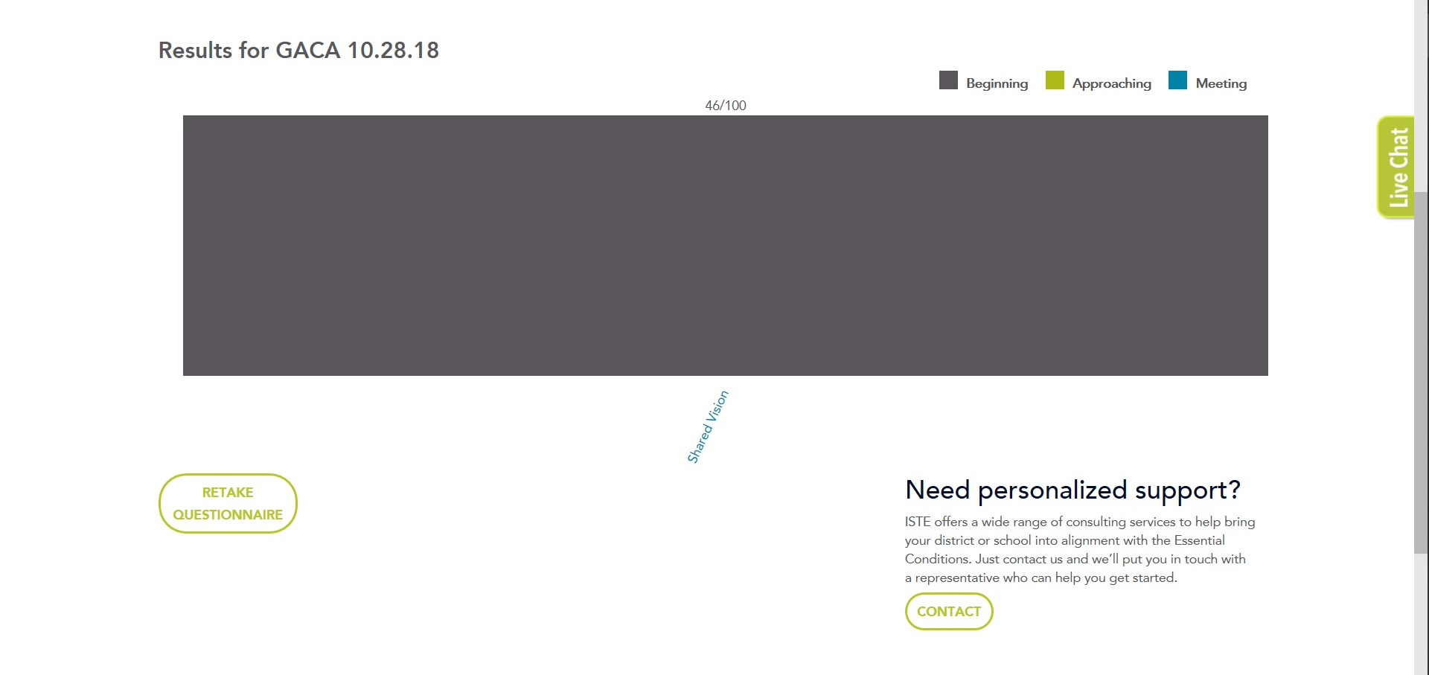

Appendix B:

Appendix C:
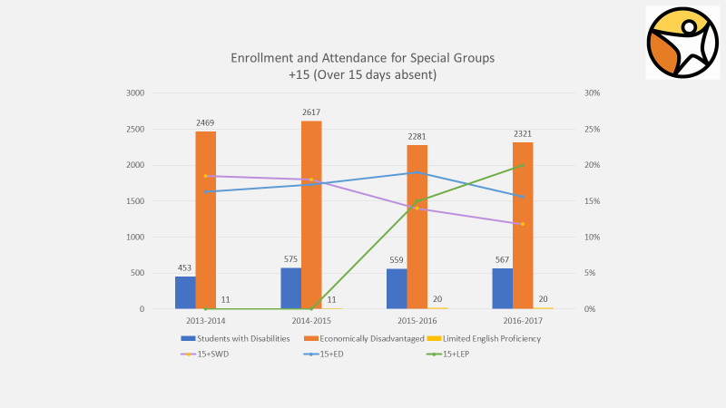

Appendix D:
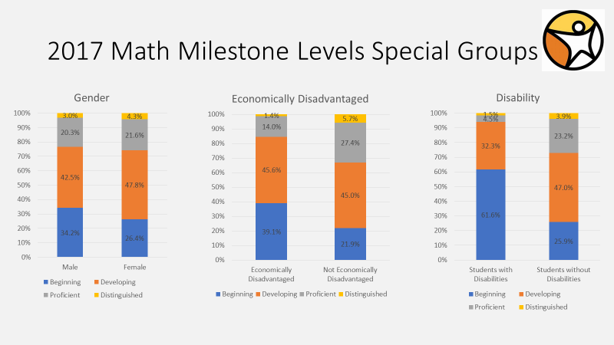

Appendix E:
